Setting up the Beer Game for individual player

- Create an Education account with beergameapp, via the page: http://app.beergameapp.com/signup
Enter your first and last names, that it is an "Education" account, enter your email address and make a password and click "Sign Up".
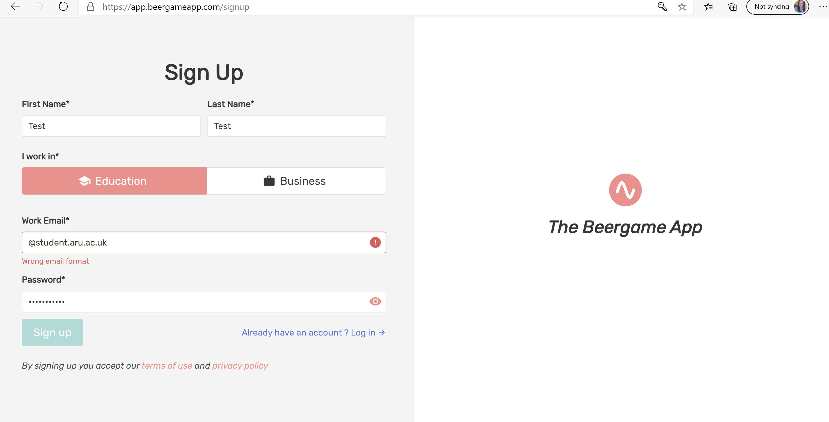

- This screen will open, click on “Click here to create a first test game”.
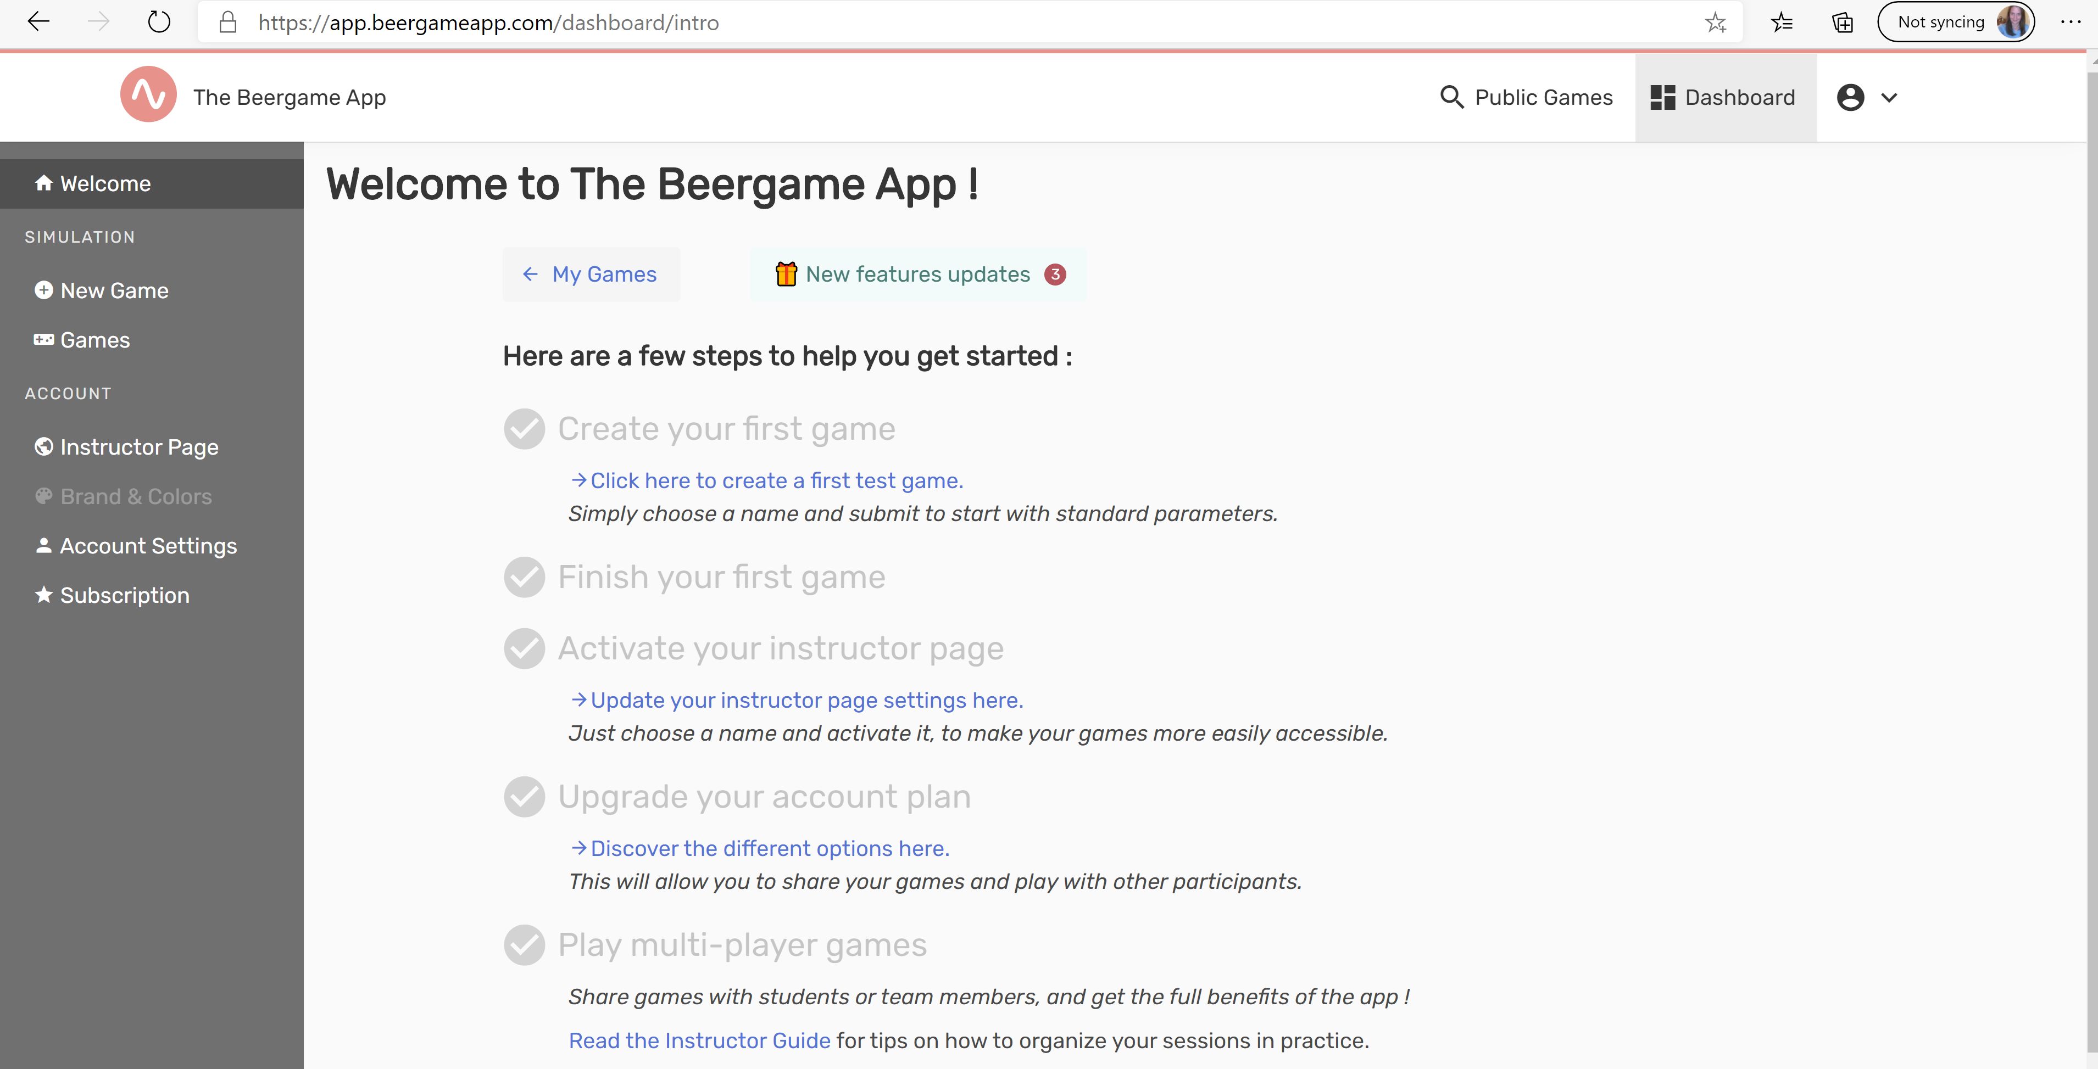

- Set the parameters: Change “Number of turns” to 20. Click on the arrow next to “Final Customer Demand” and change To week to “2”. Then in next row change Variability to “2”, as shown below:
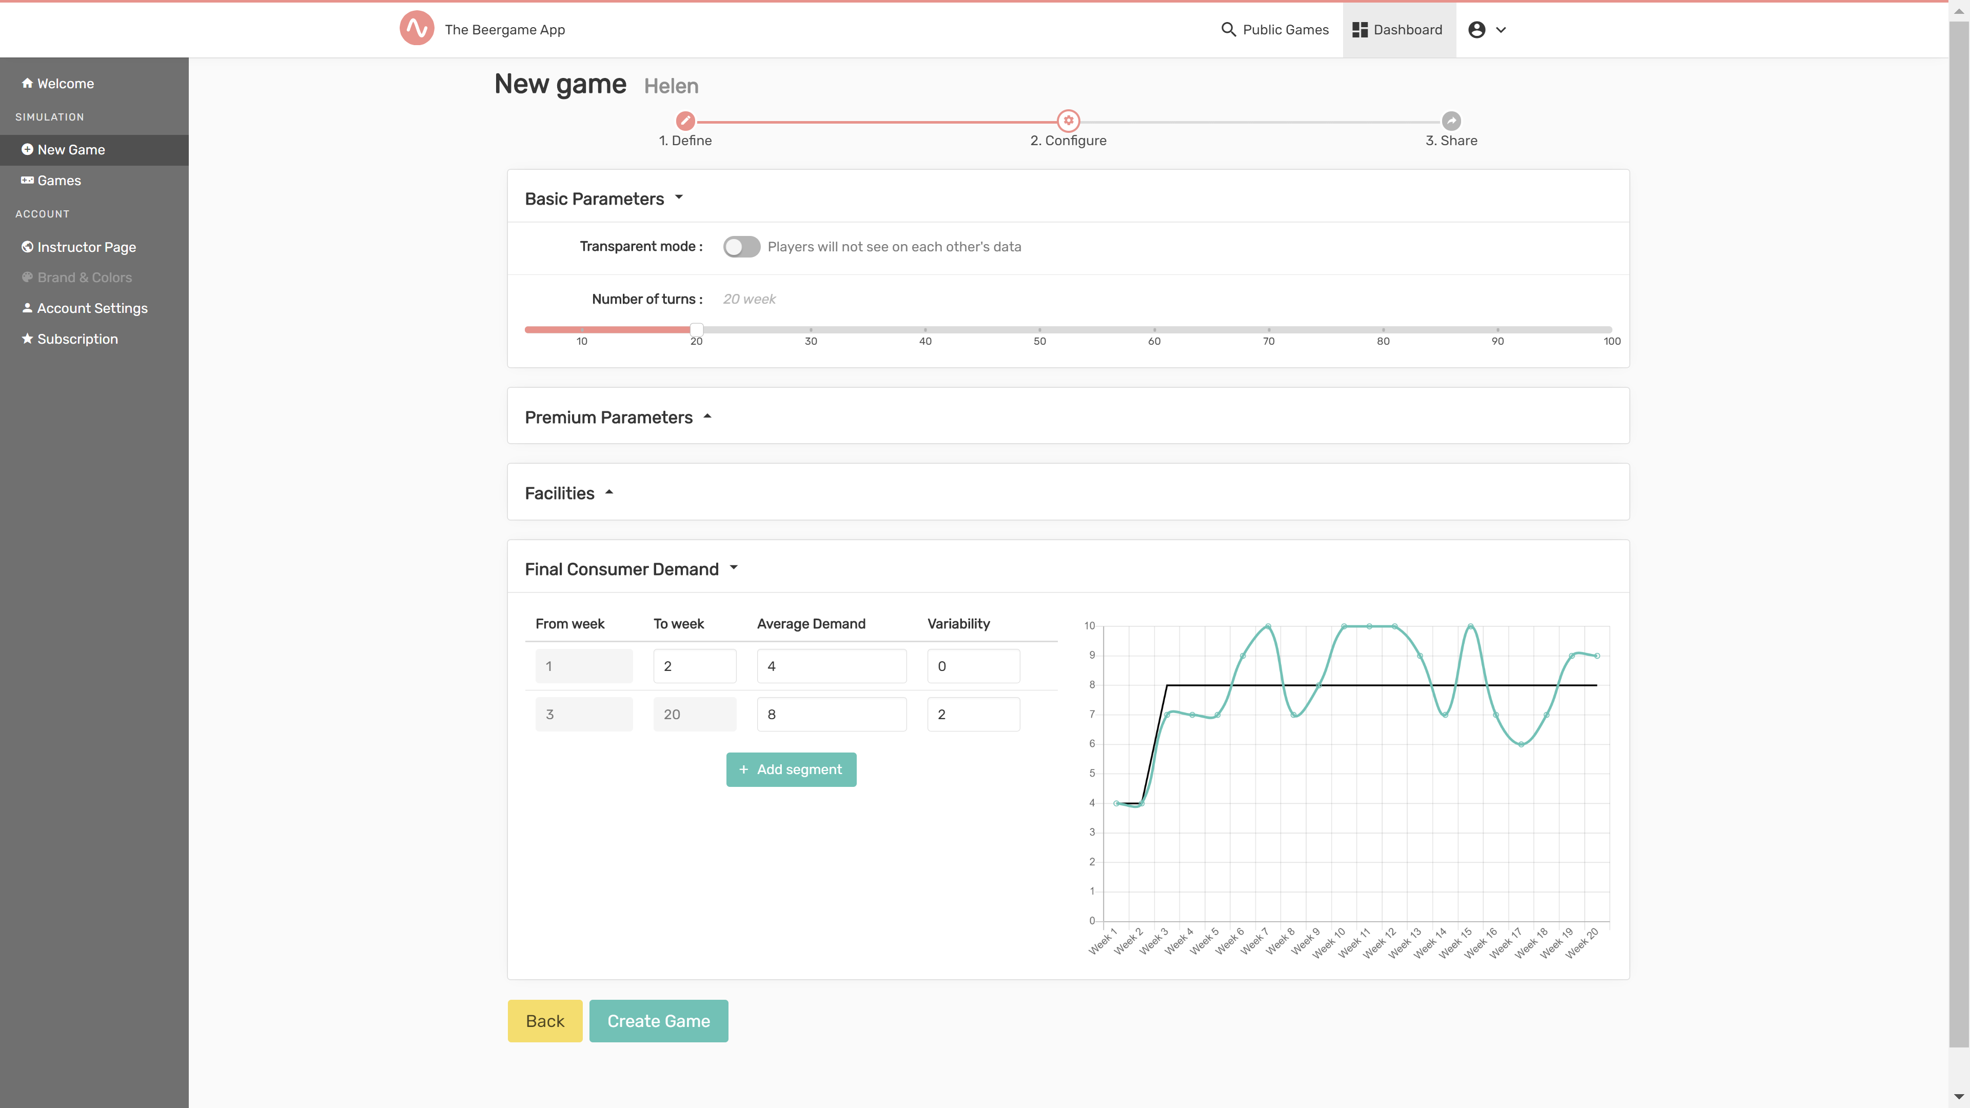

- The game will be created, click on the link, shown in blue:
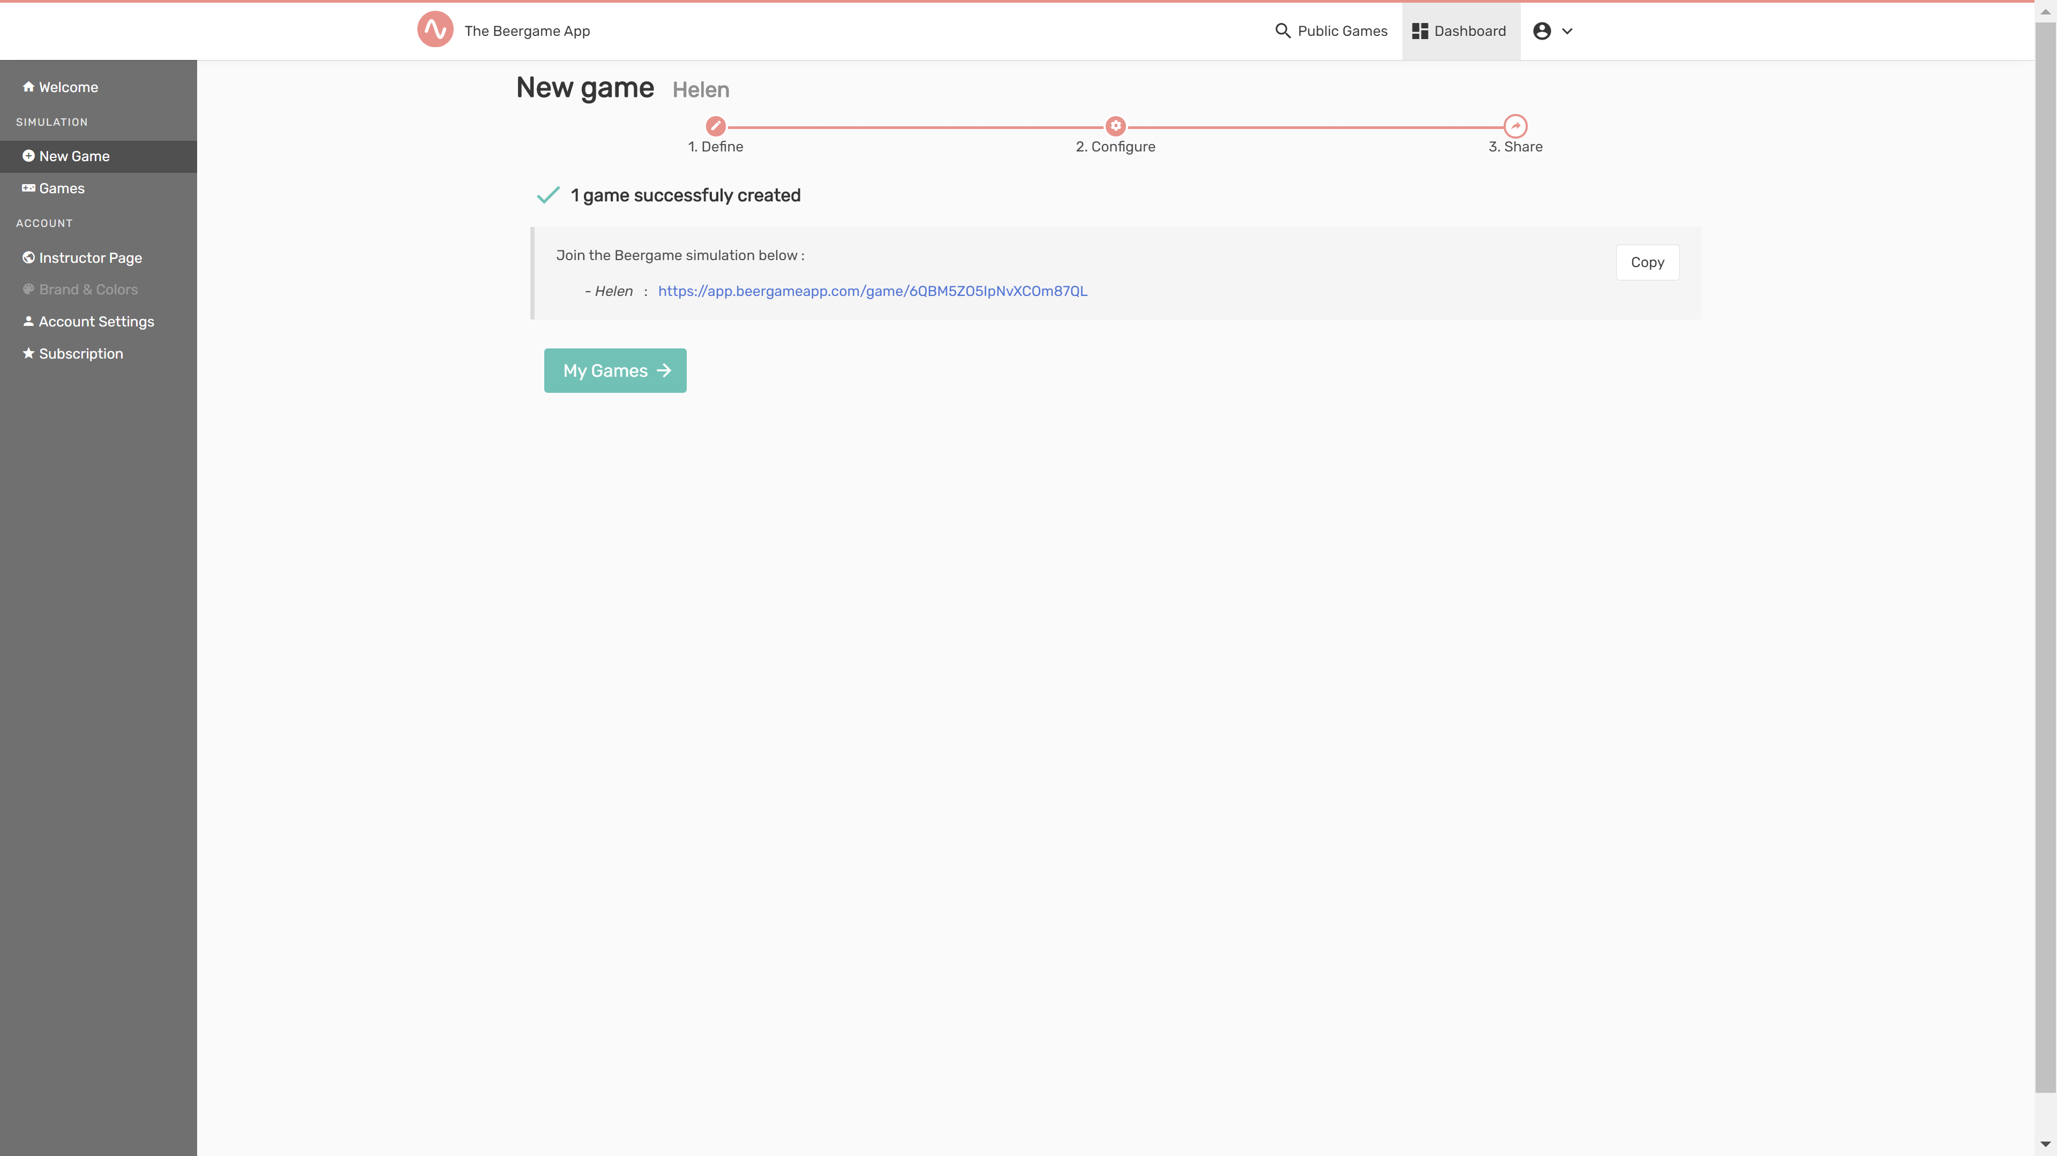

- Choose your role….
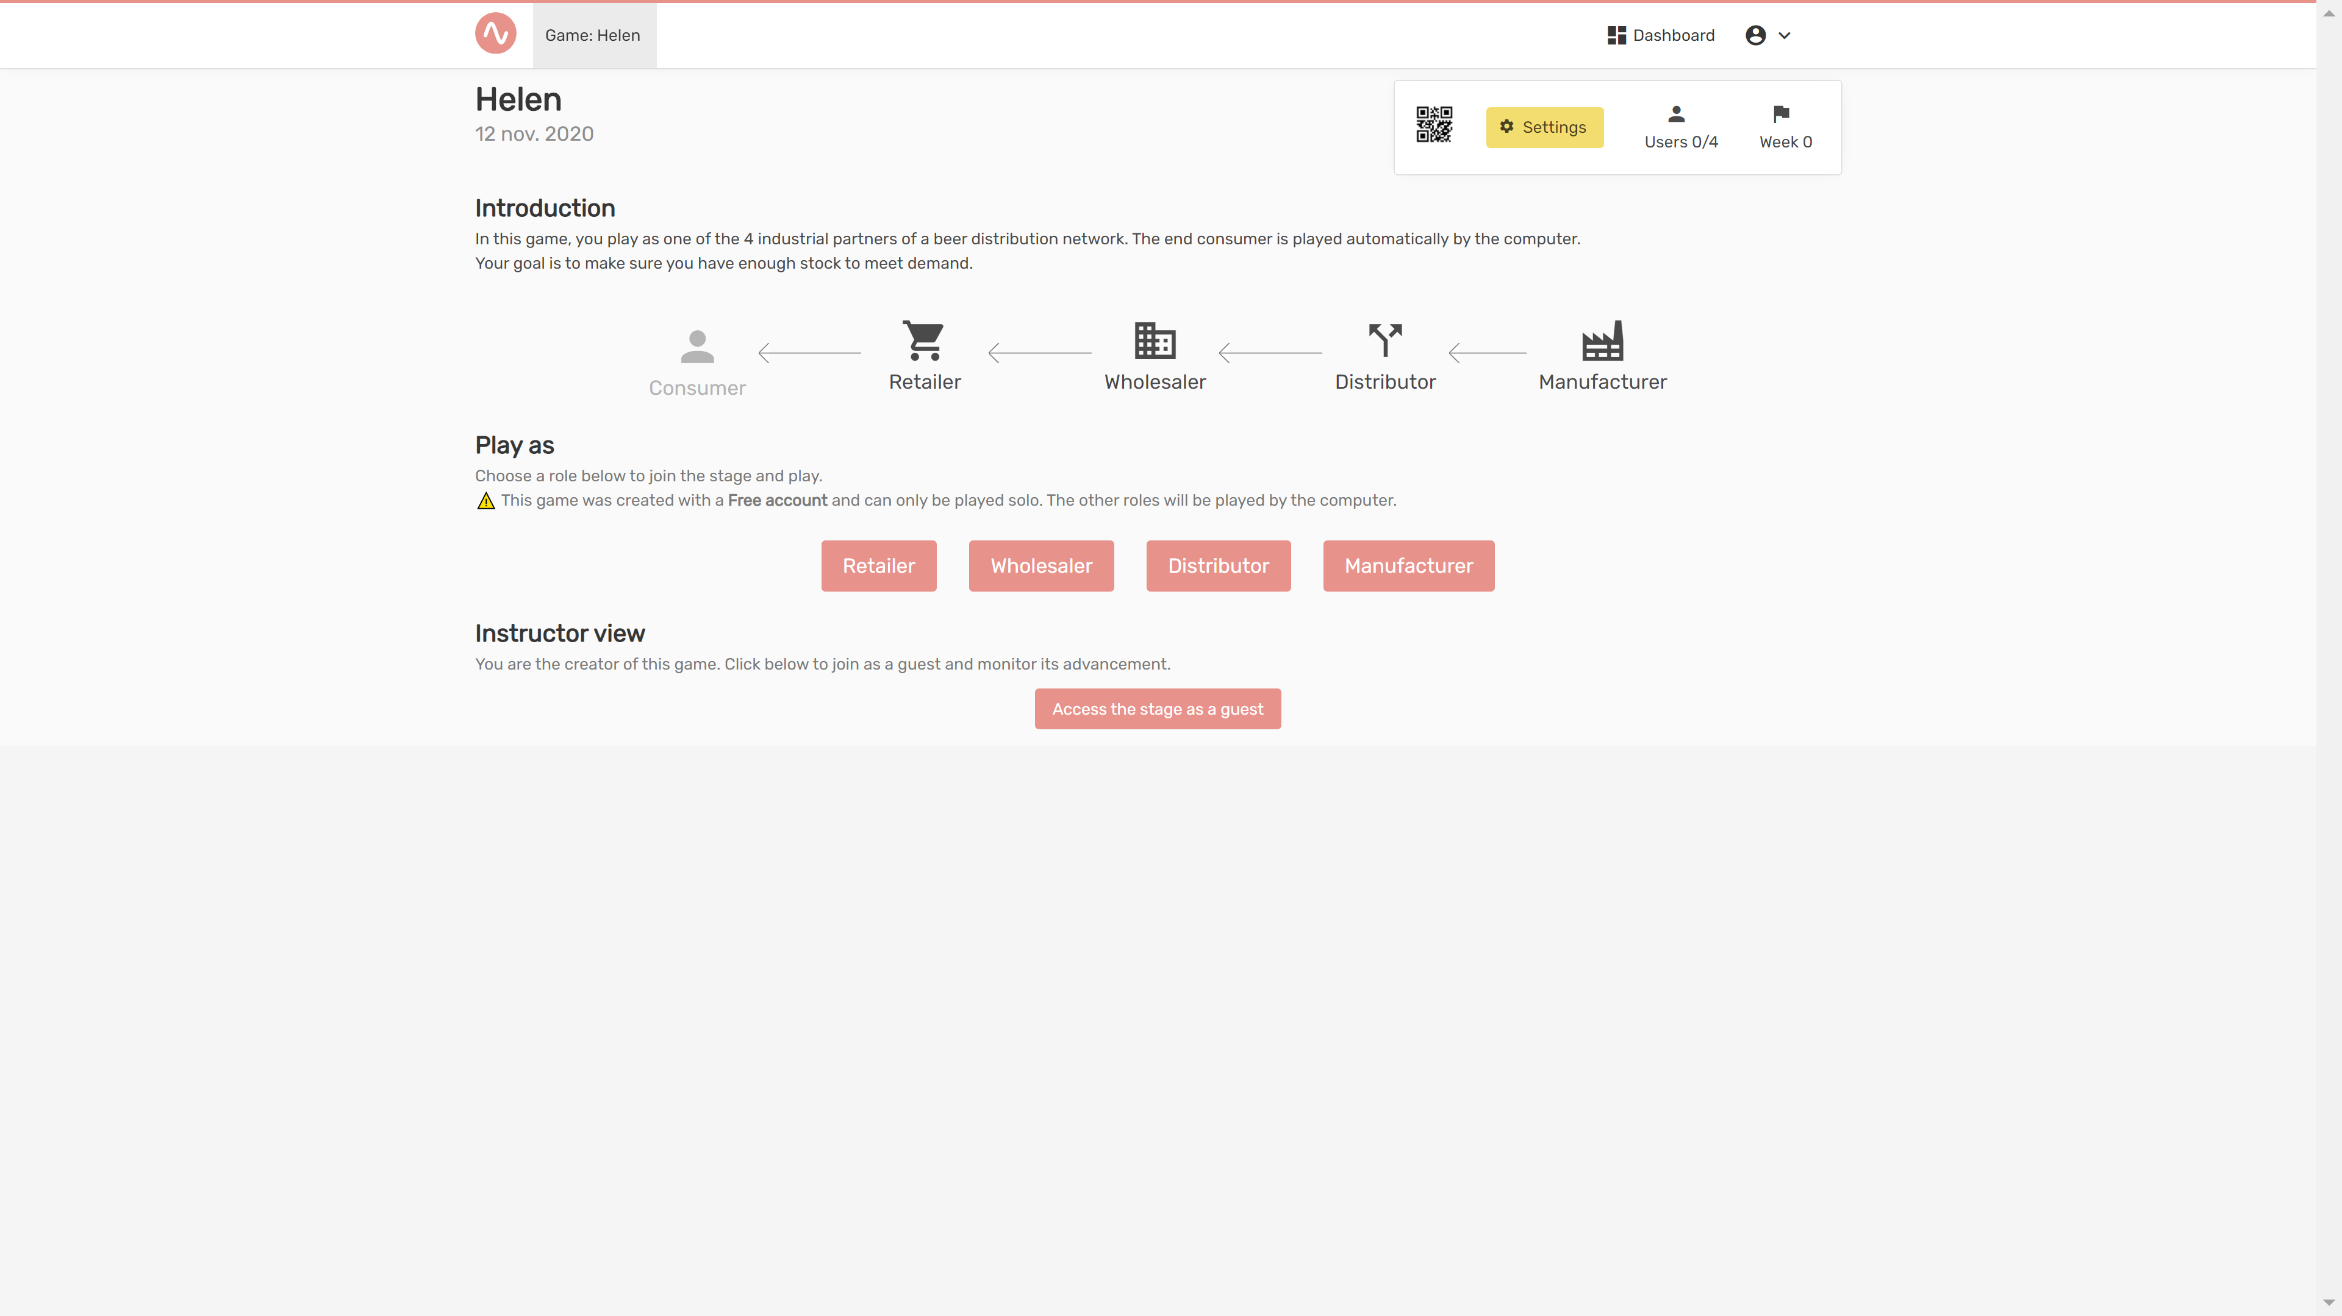

- The instructions will open, read and click “Next”, going through the instructions, then you can click “Start” to start the game.

